- Kubernetes(K8s) – It is an open source system for automatic deployment, scaling and management of containerized applications. Container might go down and need to be replaced. Kubernetes helps with this.
- Using a specific cloud service locks us into the service, you need to learn about the specifics, services, and config options of another provide if you want to switch. So advantage of kubernetes is having standardized way of describing configuration settings, that can be used across multiple cloud providers. 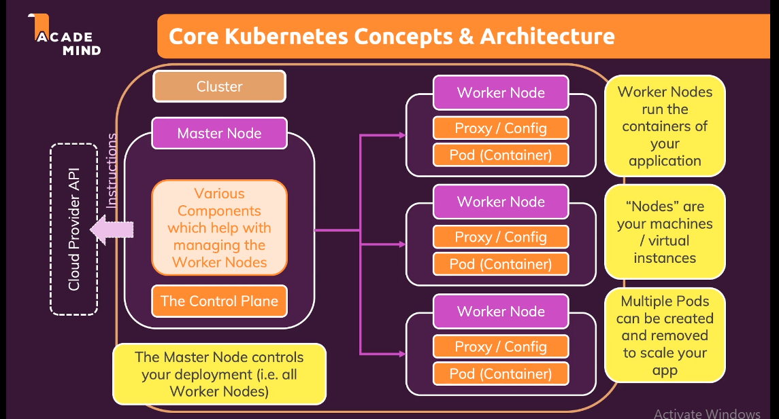 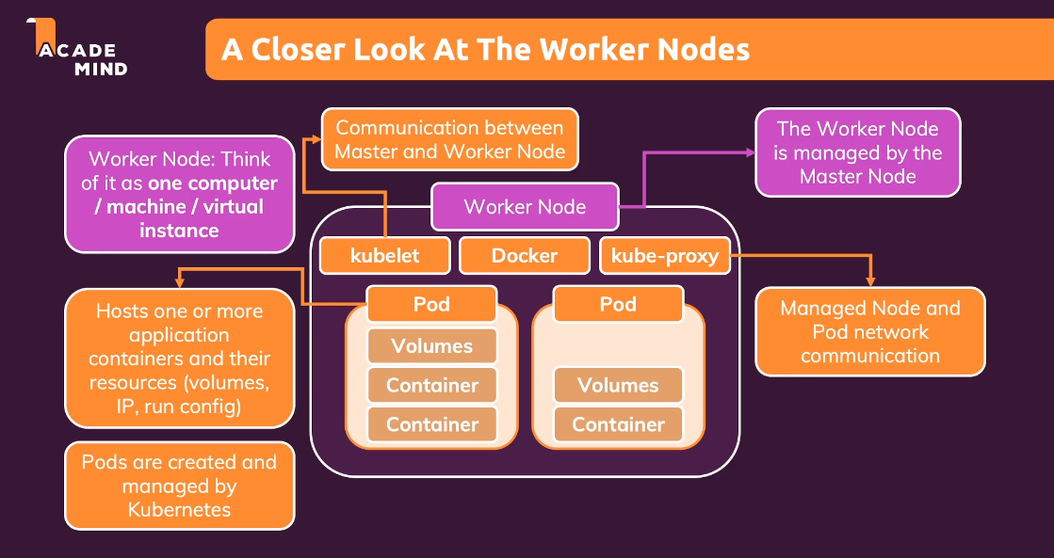 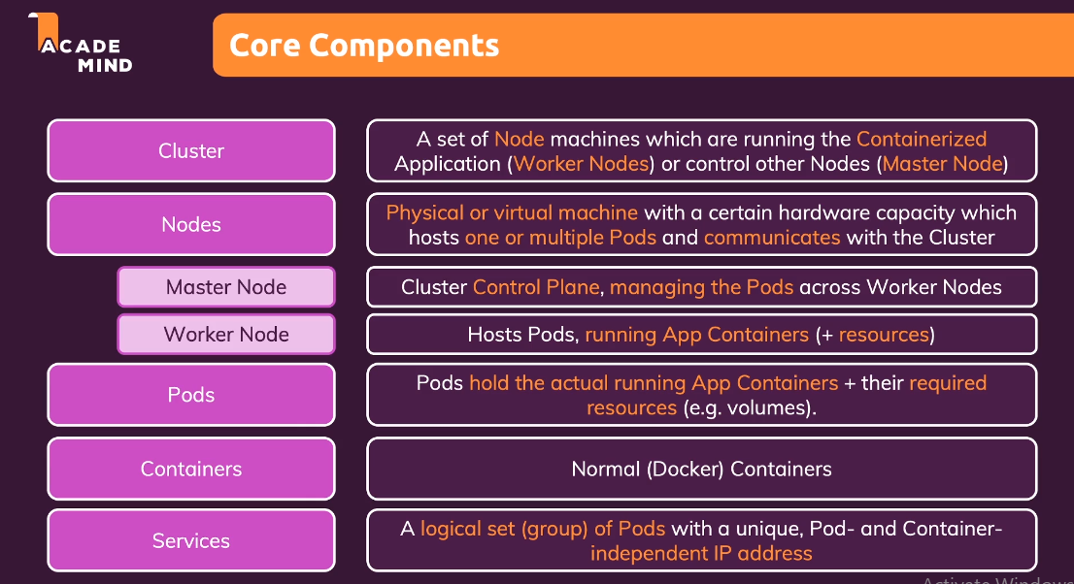 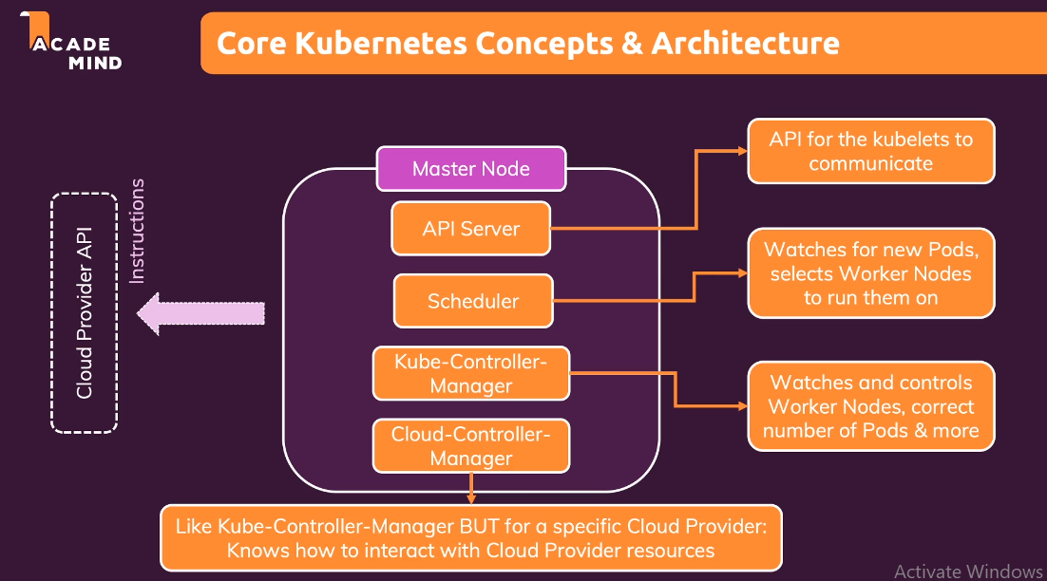
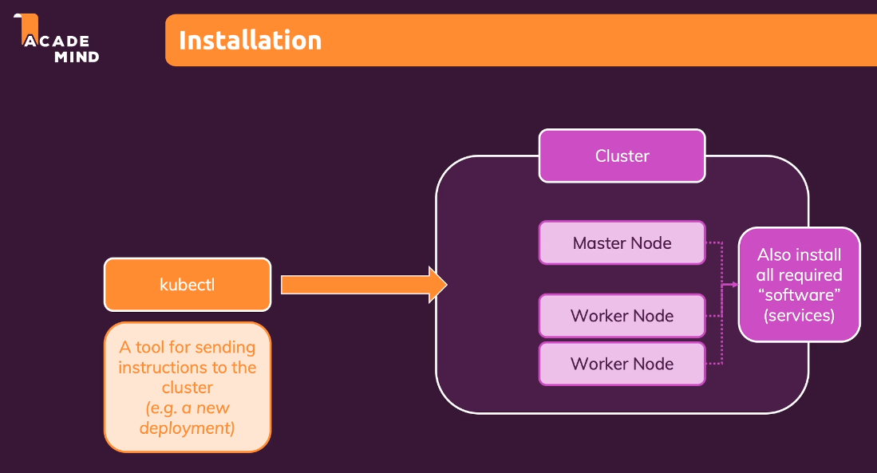
- Minikube – It is a tool that makes easy to run kubernetes locally
- Virtual Box- It is an virtualization tool to create VM

